**Client User guide**

## **1. Quick View Popup Configuration (PLP)**

The **Quick View** functionality allows customers to view product details in a popup directly from the product listing page.  
You can easily enable or customize this feature using the theme editor.

### **Steps to Configure Quick View:**

1-Log in to your **Shopify Admin Panel**.

2-From the left sidebar, go to **Online Store → Themes**.

3-Click the **Customize** button for your active theme.

4-Once the theme editor opens, click the **Settings** on the left sidebar.

5-Select **Product Cards** from the list.

6-You will now see all configurable options related to the **Quick View** popup.

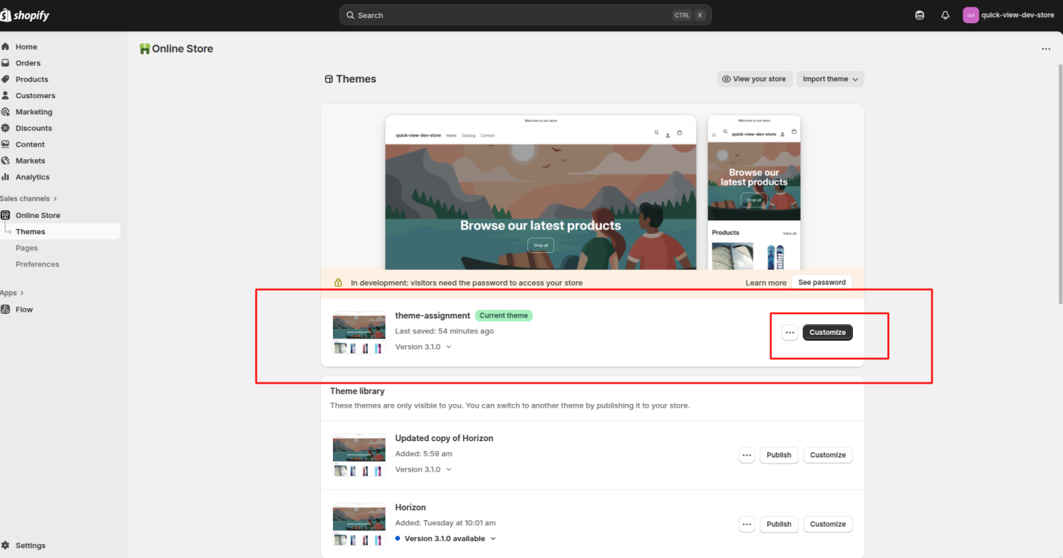

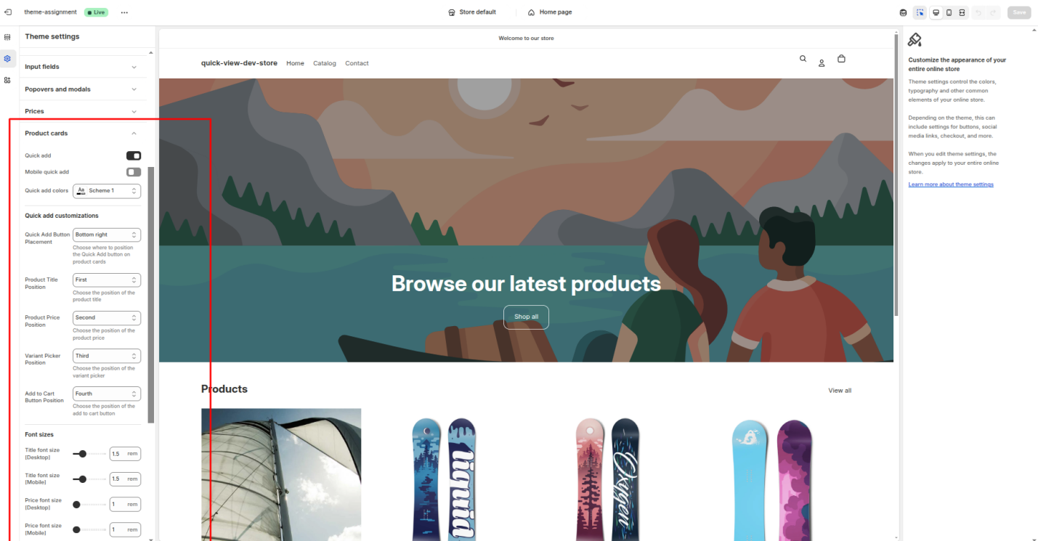

### **Available Settings:**

**Enable/Disable Quick View:** Turn the Quick View popup on or off for the PLP.

**Quick View Button Placement:** Choose where the button appears on the product card.

**Select position(First to fourth) from Dropdown for Popup:**Product Title,Product Price,Variant Picker and Add to Cart Button

**Element Order Configuration:**You can rearrange the display order of elements inside the popup.

**Default order:**Product Title,Product Price,Variant Picker and Add to Cart Button

### **Notes:**

All settings are fully responsive and adapt to different screen sizes.

You can adjust typography controls like font size from the same settings panel.

## **2. Variant Color Filtering on Product Detail Page (PDP)**

The **Variant Color Filtering** feature filters product images based on the selected color variant.  
When a user selects a color (e.g., Green, Blue, Black), only images related to that color are shown in the gallery — without reloading the page.

To make this work, you need to ensure that each product image has an appropriate **alt text** value indicating its color.

### **Steps to Add Alt Text for Images:**

1. Log in to your **Shopify Admin Panel**.
2. From the left sidebar, click **Products**.
3. Select the product you want to edit.
4. Scroll down to the **Media** section — you’ll see all uploaded images for that product.
5. Click on the image you want to update. A pop-up window will appear.
6. In the pop-up, find the **Alt text (alternative text)** field.
7. Enter the color name or descriptive value for that image, for example:
8. Click **Save** to apply your changes.

### **Notes:**

The alt text value helps the system recognize which images belong to each color variant.

Ensure each product image has the correct color name in its alt text for accurate filtering.

